2023-2024 ACADEMIC CATALOG^{i}

Educator Preparation Institute, C.C.C. (24 Credits)
Guided Pathway: College Credit Certification, Educator Preparation Institute (FULL TIME).  For more information, visit www.fgc.edu and your academic advisor. |  | 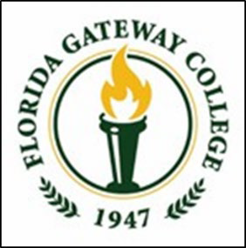
Meta-major: Education

The Educator Preparation Institute provides a pathway for individuals who have earned a four-year degree or higher from an accredited institution to enter the field of teaching through competency-based alternative certification. Graduates will be eligible for a Florida Professional Teaching Certificate with reading endorsement.

This is the sequence of courses for students interested in the educator preparation institute. It does not represent a contract, nor does it guarantee course availability. Following this pathway will help you earn a college credit certificateii. Courses that complete the certificate are listed below. As always, visit your academic advisor each semester to help you keep on track for graduation.
SEMESTER BY SEMESTER MAP FOR FULL- TIME STUDENTS
PRE-ENROLLMENT | ACTION ITEMS
- Valid Florida Statement of Eligibility
- At least a 2.5 GPA on undergraduate transcript
SEMESTER 1 | ACTION ITEMS
EDF 4251 – Classroom Management, Ethics & Law iv (3 credits) | - Program Orientation  - Complete Internship Application  - Meet with your advisor to confirm academic and career goals by the end of the semester.  - Take FTCE Subject Area Exam  - Take FTCE General Knowledge Exam (passing scores required to register for semester 2)
RED 4044 – Foundations and Application of Language and Reading iv
(3 credits)
TSOL 4083 – ESOL Strategiesiv (3 credits)
SEMESTER 2 | ACTION ITEMS
RED 4519 – Diagnosis and Intervention in Reading iv (3 credits) | - Take FTCE Professional Educator at end of semester
EDF 4280 – Instructional Strategiesiv (3 credits)
EDF 4430 – Classroom Assessmentiv (3 credits)
RED 4941 – Internshipiv (3 credits)
TOTAL SEMESTER CREDIT HOURS: 12
SEMESTER 3 | ACTION ITEMS
EDF 4214 – The Teaching and Learning Processiv (3 credits) | - Apply at the FLDOE for professional certificate  - Schedule Exit Interview
TOTAL SEMESTER CREDIT HOURS: 3
CDEI DEGREE MINIMUM: 24 SEMESTER CREDIT HOURS|PATHWAY TOTAL: 24 CREDIT HOURS
- Degree plans may change in later catalogs. You may use this pathway if you entered the college on or before this date.
- Students must earn at least 25% of the credit hours (15 hours) required for graduation through instruction by FGC to award the degree.
- This is not an official degree plan. For official degree requirements, click here.
- You must earn a grade of "C" or better in all EPI classes.

