FGC RN-BSN
Admission Packet
2023

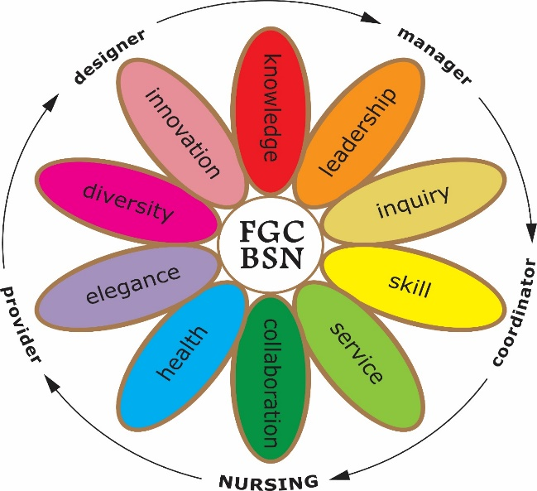

RN-BSN Admission Application Checklist:

Prior to completing this paper application, please apply as a Baccalaureate level student on the FGC website https://apply.fgc.edu/Ellucian.ERecruiting.Web.External/pages/welcome.aspx

- A copy of your current American Heart Association (AHA) Basic Life Support for Health Care Provider Card or Professional Rescuer for American Red Cross (ARC) Card
- A copy of your current unencumbered, active RN License which must be current throughout the duration of the Program. Students may start the BSN program without a current license, but this must be completed prior to the end of their first minimester.
- Transcripts for colleges/universities. (Do not include FGC or LCCC transcripts).
- One paragraph stating why you are wanting to complete your BSN degree and what are your future career goals.
- One (1) signed professional letter of recommendation.
- Resume
- The ability to pass a Level II background check and drug screening (10 Panel) plus, alcohol test (to be completed later).
- A grade of ‘C’ or better in all general education requirements and a GPA of 2.5 or higher in all ASDN prerequisite courses.
- To apply for a scholarship, you must complete a FAFSA application www.fafsa.ed.gov FGC school code: 001501.
**To discuss information pertinent to the RN-BSN program contact Dr. Melissa Davis at 386-754-4352 or at Melissa.davis1@fgc.edu

Required for the RN-BSN Program
- Successful completion of two credits of the same foreign language in high school, completion of a post-secondary course at the elementary 2 level (meaning the second course in a foreign language sequence) in one foreign language or American Sign Language (ASL).
- Complete at least one core course from each of the general education subject areas of communication, humanities, mathematics, natural sciences, and social sciences. General Education core course options are identified in Rule 6A-14.0303.
- Complete civic literacy requirements; Successfully complete POS1041 American Government, or AMH2020 United States History from 1865 AND Civic Lit Exam.
*All BS/BAS degrees must satisfy the statewide Civic Literacy, foreign language, and general education core requirement for graduation. Please see the catalog. Please call our Advisement office at 386-754-4222 to discuss the general education requirements

Courses for the RN-BSN Program
Lower Division Nursing Courses: 42 Credit Hours (Associate Nursing Courses)
Prerequisites Earned in ASDN Degree: 30 Credit Hours (Should have been completed as part of ASDN Degree)
BSC 2085 | Anatomy and Physiology I 3 credits
BSC 2085L | Anatomy and Physiology I Lab 1 credit, 3 Lab hours weekly
BSC 2086 | Anatomy and Physiology II 3 credits
BSC 2086L | Anatomy and Physiology II Lab 1 credit, 3 Lab hours weekly
ENC 1101 | Freshman Composition I 3 credits
DEP 2004 | Human Growth and Development 3 credits
HUN 1201 | Human Nutrition 3 credits
MCB 2010 | Microbiology 3 credits
MCB 2010L | Microbiology Lab 1 credit, 3 Lab hours weekly
Any Gen Ed SPC | Any Gen Ed SPC course 3 credits (may be taken as a corequisite)
ENC 1102 | Freshman Composition II 3 credits (may be taken as a corequisite)
 | One of the following:
HUM 2020 | Intro to Humanities 3 credits (may take as a corequisite) OR
PHI 2010 | Intro to Philosophy 3 credit (may take as a corequisite) (whichever not completed in AS degree).
 | One of the following:
MAC 1105 | College Algebra 3 credits OR
MGF 1106 | Math for Liberal Arts 3 credits OR Higher-level math 3 credits
 | One of the following:
AMH 2020 | United States History from 1865 3 credits OR (May take as a co-requisite & must also pass Civic Literacy Exam)
POS 1041 | American Government 3 credits (May take as a co-requisite & must also pass Civic Literacy Exam)

Pre-Req’s (9 credits)
STA 2023 | Elementary Statistics 3 credits
PSY 2012 | General Psychology I 3 credits
 | One of the following:
SYG 1000 | Introduction to Sociology 3 credits OR
SYG 1310 | Human Relations 3 credits OR
SYG 1320 | Deviant Behavior 3 credits OR
SYG 2300 | Introduction to Social Psychology 3 credits OR
SYG 2430 | Marriage and the Family 3 credits

BSN Course (31 credits Sequence depending on start date)
NUR 3846 | Nursing Theory
NUR 3125 | Pathophysiology
NUR 3826 | Ethical and Legal Issues in Health Care
NUR 4655 | Nursing in Diverse Cultures
NUR 3145 | Pharmacology
NUR 3065C | Nursing Assessment (45 clinical lab hours)
NUR 3164 | Nursing Research and Informatics
NUR 4636C | Community Health (45 clinical practicum hours)
NUR 4837 | Health Care Policy and Economics
NUR 4827 | Leadership and Management in Professional Nursing

Nursing, B.S. Total 121 Credit Hours

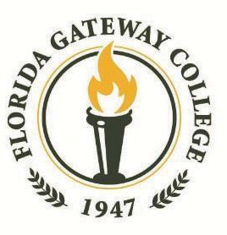
Bachelor of Science in Nursing
Program Application

Student Contact Information:
FGC Student ID# | Last Name: |  |  |  | First Name: |  | MI:
Address:

City: |  |  | County: |  |  | State: | Zip:
Home Phone: |  | Cell Phone: |  | Email Address:
In Case of Emergency, Notify:

Occupation:

Days or shift(s) you usually work:

Best Time & way to contact you (text, email, phone call, etc.):

Education:
Name of High School or Equivalency Issuer: | Name if different than the above: | City | State: | Date/Year
College Name & Location | Name if different than the above: | Date of Attendance: | Major: | Degree:
College Name & Location | Name if different than the above: | Date of Attendance: | Major: | Degree:
College Name & Location | Name if different than the above: | Date of Attendance: | Major: | Degree:
Page 1 of 2
Bachelor of Science in Nursing
Program Application

Bachelor Of Science in Nursing Checklist:
Acceptance to the RN-BSN program will be based on the completion of all required documentation.
- Apply as a Baccalaureate level student on the FGC website https://apply.fgc.edu/Ellucian.ERecruiting.Web.External/pages/welcome.aspx
- A copy of your current American Heart Association (AHA) Basic Life Support for Health Care Provider Card or Professional Rescuer for American Red Cross (ARC) Card
- A copy of your current unencumbered, active RN License which must be current throughout the duration of the Program. Students may start the BSN program without a current license, but this must be completed prior to the end of their first minimester.
- Transcripts for colleges/universities. (Do not include FGC or LCCC transcripts).
- One paragraph stating why you are wanting to complete your BSN degree and state your future career goals.
- One signed professional letter of recommendation.
- Resume
- All BS/BAS degrees must satisfy the statewide Civic Literacy, foreign language, and general education core requirement for graduation. Please see the catalog. Please call our Advisement office at 386-754-4222 to discuss the general education requirements
*I understand that completion of a mandatory orientation session is required after program admission and prior to beginning classes.
**I hereby certify that the facts set forth in this application are true and complete to the best of my knowledge. I understand that the discovery of any falsification of this information will result in denial of admission or prompt dismissal from the program. Florida Gateway College is hereby authorized during the admission process and/or during my tenure as a student, if admitted, to make any investigation that is deemed necessary concerning the above information with regard to my suitability to practice.
Signature: | Date:

Return completed application by mail, fax, email, or in-person to:
Florida Gateway College, Attn: RN-BSN Program, 149 S.E. College Place, Lake City, Florida 32025
Phone: (386) 754-4448 Fax: (386) 754-4948 email: emily.davis@fgc.edu In-person: Building 103, Room 141 or 104
For Office Use Only
- AHA or ARC CPC Card
- RN License
- Transcript (if required)
- Paragraph – Future Goals
- Resume
- Letter of Recommendation
Florida Gateway College does not discriminate in education or employment related decisions on the basis of race, color, ethnicity, national origin, gender, religion, disability, age, marital status, genetic information, sexual orientation, pregnancy, or any other legally protected status in accordance with the law. The equity officer is Cassandra Buckles, Executive Director of Human Resources, Building 001, Room 116, 149 SE College Place, Lake City, FL 32025, and may be reached at cassandra.buckles@fgc.edu or (386) 754-4313.
Page 2 of 2 1/18/23 MD

